# Wildflower Phenology: A Case Study (Answer key)

Phenological Responses to a Changing Climate 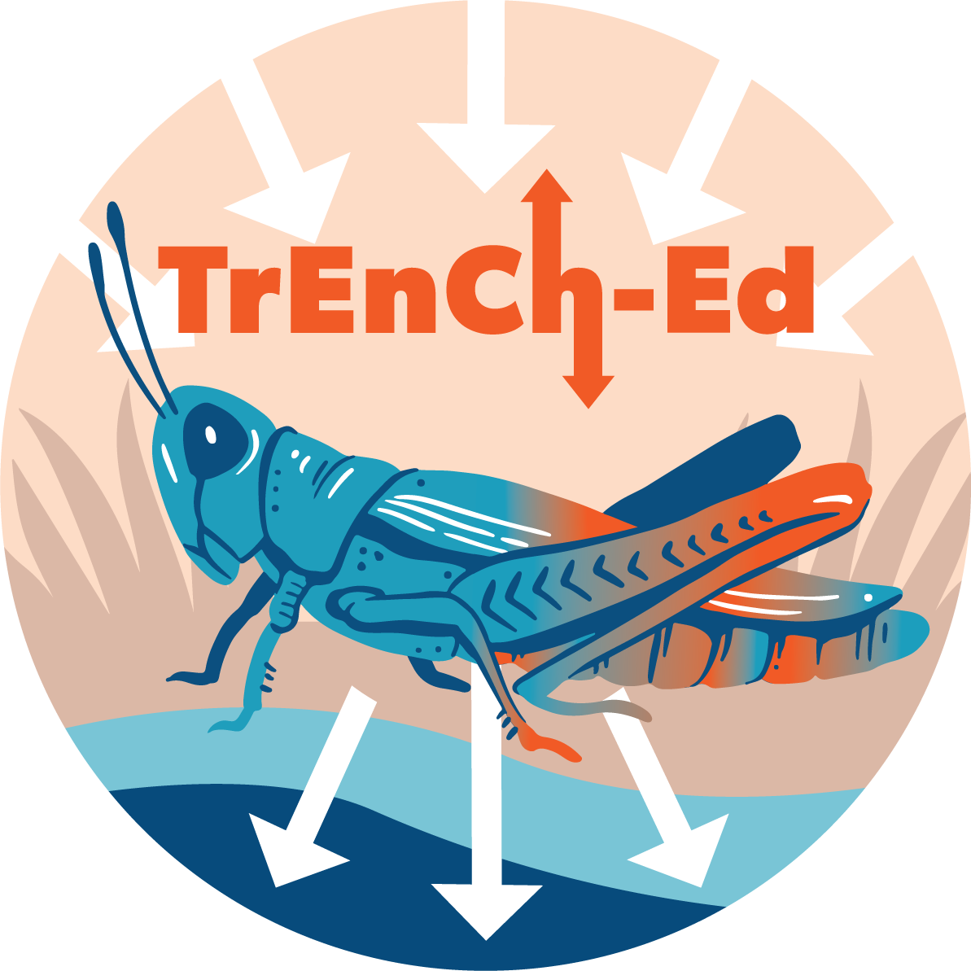

## [Link to the visualization](https://huckley.shinyapps.io/PlantPhenology/)

## [Link to TrEnCh-Ed](https://trench-ed.github.io/#)

## Objectives

* Describe changes in temperature over time.
* Analyze the impacts of climate on wildflower phenology.
* Test hypotheses about how the timing of flowering responds to temperature and propose potential mechanisms.
* Consider the ecosystem implications of phenology.

## Core Concepts -- *BioCore*

* Physiology: Evolution
* Physiology: Systems
* Ecology & Evolutionary Biology: Systems

## Instructions

### Background

1. Define phenology.  
   The timing of important life events such as when birds migrate or when plants flower.
2. Other than the first flowering date, what are three phenological events for plants?  
   Germination date, buds bursting date, fruit production date, last flowering date, flowering duration, leaf fall, etc.
3. Why is flowering an important phenological event?

Many flowering species rely on pollinators for their reproduction, so the flowering has to coincide with their presence.

### Temperature and First Flowering Date

The app includes a figure that will allow you to look at changes in temperature over a period of 122 years (1893-2015). There is a lot of natural variability in the data (i.e. differences between individual years), so to help you see broad long term patterns, look at the blue trendline instead of the scattered data points. Answer the following questions:

1. Keeping the range of years from 1893 to 2015, select four different months and watch how the graph changes. The months you select should be months you consider to be representative of each of the four seasons: winter, spring, summer, and fall.
   1. Why is the y-axis different in each of the four months you selected?   
      Because the temperature varies widely throughout the year.
   2. How does the x-axis change between the four months?  
      It does not change.
   3. In which month was the slope of the blue trendline the steepest? Interpret this result by describing the relationship with temperature over time.   
      It was the steepest in April. This implies that spring temperature is rising more quickly than other seasons’ temperatures.
   4. In which month was the p-value the largest? Interpret this result by describing the relationship with temperature over time.  
      It was the largest in January. This implies that there is no significant change in temperature over the years.
2. Plot annual average temperatures (find this at the bottom of the list of months) across the entire time period.
   1. Around how much has the average annual temperature increased since the 1890s?  
      About 1.5 °C.
   2. If the current trend continues, what will the average annual temperature in Concord be in 2075?  
      Around 10.5 - 11 °C.
3. The timing of flowering is highly dependent on temperature. Hypothesize which months are likely to have the largest effect on flowering phenology and explain your reasoning.  
   Early spring temperatures are likely to have the greatest impact on flowering phenology. This is because they flower in spring, and the timing has to match with the presence of the pollinators for successful fertilization.

### Relationships between temperature and First Flowering Date (FFD)

1. Create scatterplots for all species, showing annual temperature on the x-axis.
   1. For which two species does phenology advance with warming (you see a clear negative slope)?  
      *Amelanchier canadensis* and *Vaccinium corymbosum.*
   2. What do these species have in common?  
      Both species flower early in the year (between April and May)
2. Create scatterplots for all species, showing January-April temperature on the x-axis.
   1. Now, which species have flowering phenologies that advance with warming?  
      All species do.
   2. Keeping in mind the months that warmed the most over the years, what can we conclude about the flowering dates?

With increased spring temperatures, all of the species have earlier flowering dates. Spring months temperatures are increasing more than the other months over the years, which suggests that the species are flowering earlier and earlier.

1. Propose a hypothesis for why some species show higher or lower slopes when you plot FFD against temperature. (There are many possibilities!)  
   Example hypotheses:

Species in more exposed environments are more sensitive to the change in air temperatures compared to those in protected environments.

Species that rely on very specific pollinators are more sensitive to the change in temperatures over those that rely on various pollinators.

### Synthesis

1. What impacts could changing FFD’s have on other species (including animals) in the ecosystem?

Plants are an important food source for many animals. The shift in FFD can create a mismatch between their emergence and the time that their food is around, which can disrupt the whole food chain.

1. How could the data used in this study be improved? What other sources of data can be used to study changes in phenology or abundance of species over time?

Data can be improved by increasing the sample size or including data on snow. Data from herbarium collections or line crowd-sourcing platforms (like iNatrualist) can be included in this study etc.